**SENTIMENT ANALYSIS OF MOVIE REVIEWS USING ROBERTA**

**AND**

**DATA AUGMENTATION**

## PROJECT REPORT

***Submitted by***

|  |  |
| --- | --- |
| **HARIHARAN V** | **727621BCS040** |
| **RAHUL KRISHNAN A** | **727621BCS042** |
| **KAVIN M** | **727621BCS048** |

***in partial fulfillment of the requirements for the degree of***

**BACHELOR OF ENGINEERING IN**

**COMPUTER SCIENCE AND ENGINEERING**

**DR. MAHALINGAM COLLEGE OF ENGINEERING AND TECHNOLOGY**

**AN AUTONOMOUS INSTITUTION AFFILIATED TO ANNA UNIVERSITY CHENNAI 600 025**

**APRIL 2025**

# DR. MAHALINGAM COLLEGE OF ENGINEERING AND TECHNOLOGY, POLLACHI -642 003

**(AN AUTONOMOUS INSTITUTION AFFILIATED TO ANNA UNIVERSITY, CHENNAI - 600 025)**

## BONAFIDE CERTIFICATE

Certified that this project report titled **“Sentiment Analysis of Movie Reviews using RoBERTa and Data Augmentation”** is

the bonafide work of

|  |  |
| --- | --- |
| **HARIHARAN V** | **727621BCS040** |
| **RAHUL KRISHNAN A** | **727621BCS042** |
| **KAVIN M** | **727621BCS048** |

who carried out the project work under my supervision.

|  |  |
| --- | --- |
| **SUPERVISOR**  Mr. P. Boopathi Rajan Assistant Professor (SS) Department of CSE Dr.Mahalingam college of Engineering and Technology  Pollachi- 642003 | **HEAD OF THE DEPARTMENT**  Dr. R. Sivaganesan Professor Department of CSE  Dr.Mahalingam college of  Engineering and Technology Pollachi- 642003 |

Submitted for the Autonomous End Semester project Viva-Voce Examination held on

**INTERNAL EXAMINER EXTERNAL EXAMINER**

# Dr. Mahalingam College of Engineering and Technology, Pollachi-642003

## Academic Year: 2024 - 2025

**TRL, SDG and Similarity Compliance Certificate**

**Project Title:** Sentimental Analysis on Movie Reviews using RoBERTa and Data Augmentation

**Course Code:** 19CSPN6801

**Department and Semester:** CSE / VIII

**Technology Readiness Level (TRL) of the Project**

**:**

**Sustainability Development Goals (SDG)-Goal Name :**

**Similarity % from Turnitin Software**

**:**

***I/we hereby declare that this project report is original and complies with the institution's similarity guidelines.***

|  |  |  |
| --- | --- | --- |
| **S.No.** | **Names and Roll Numbers of Students** | **Signature of the Students** |
| 1. | HARIHARAN (727621BCS040) |  |
| 2. | RAHUL KRISHNAN A (727621BCS042) |  |
| 3. | KAVIN M (727621BCS048) |  |

***Verified by***

Name & Signature of the Guide Head of the Department

***Endorsed by***

INTERNAL EXAMINER EXTERNAL EXAMINER

# ABSTRACT

**ABSTRACT**

Sentiment analysis has become an essential tool in Natural Language Processing (NLP), especially for interpreting user-generated content such as movie reviews, social media posts, and product feedback. This project proposes an advanced sentiment classification system based on the RoBERTa (Robustly Optimized BERT Approach) transformer model, augmented with synonym- based data augmentation techniques to improve generalization and accuracy.

The IMDb dataset, comprising 50,000 movie reviews labeled as positive or negative, was used in this study. A synonym replacement strategy leveraging the WordNet lexical database was employed to generate augmented samples, effectively doubling the dataset and introducing lexical variability. The RoBERTa-base model was then fine-tuned on this enriched dataset using TensorFlow and Hugging Face’s Transformers library.

The proposed model demonstrated superior performance over traditional and recent hybrid models, achieving a classification accuracy of 92.72%, an F1- score of 0.93, and an AUC of 0.98. These results substantially outperform baseline models such as SAE-LSTM (87%) and BERT-based systems (85.4%). In addition, a web-based interface was developed to allow real-time sentiment prediction from user-submitted text, offering practical usability in customer feedback analysis and opinion mining.

This study showcases the efficacy of combining transformer-based architectures with data augmentation strategies, setting a new benchmark for sentiment analysis tasks on review-based corpora.

## ACKNOWLEDGEMENT

We would like to express my sincere thanks and a deep sense of gratitude to the Management**, Dr.C.Ramasamy, Ph.D.**, Secretary and **Dr.S.V.Subramanian, PhD.**, Joint Secretary, NIA Educational Institutions and **Dr.P.Govindasamy, Ph.D.**, Principal for providing us necessary facilities to carry out this project.

We are very proudly rendering our thanks to our Vice principal **Dr.A.SenthilKumar, Ph.D.**, for the facilities and the encouragement given by him to the progress and completion of our project.

We proudly render our immense gratitude to the Associate Dean Academics **Dr.K.Vijayakumar Ph.D**., for his effective leadership, encouragement and guidance in the project.

We also heartily thank **Dr.D.Sivaganesan Ph.D.**, Head of the Department of Computer Science and Engineering, for providing us the facilities for the completion of this work.

We express our deep sense of gratitude with sincerity to our guide **Mr.P.Boopathirajan, M.E.**, Assistant Professor (SS), Department of Computer Science and Engineering, for her valuable suggestions and guidance shared during the project.

We sincerely thank our project coordinator, **K.Radha, M.Tech**., Assistant Professor (SS), Computer Science and Engineering, for her valuable support and encouragement in developing this project successfully.

Finally, We thank all those who had contributed directly and indirectly towards the success of this project.

# TABLE OF CONTENTS

**TABLE OF CONTENTS**

|  |  |  |
| --- | --- | --- |
| **CHAPTER NO** | **TITLE** | **PAGE NO** |
|  | **ABSTRACT** | **iv** |
|  | **LIST OF TABLES** | **xi** |
|  | **LIST OF FIGURES** | **xii** |
|  | **LIST OF ABBREVIATIONS** | **xiii** |
| **1** | **INTRODUCTION** | **1** |
|  | 1.1 MACHINE LEARNING | 2 |
|  | 1.2 OBJECTIVES OF THE PROJECT | 3 |
|  | 1.3 PROBLEM STATEMENT | 3 |
|  | 1.4 ORGANISATION OF THE PROJECT WORK | 4 |
| **2** | **LITERATURE SURVEY** | **5** |
|  | 2.1 HYBRID SAE-LSTM MODEL FOR SENTIMENT ANALYSIS | 6 |
|  | 2.2 NNS FOR MOVIE REVIEWS | 6 |
|  | 2.3 SENTIMENT ANALYSIS FOR MOVIE REVIEWS | 7 |
|  | 2.4 SENTIMENT ANALYSIS ON MOVIE REVIEWS | 7 |
|  | 2.5 ENSEMBLE TECHNIQUES FOR SENTIMENT ANALYSIS | 8 |
|  | 2.6 SENTIMENT ANALYSIS OF ONLINE MOVIE REVIEWS | 8 |
|  | 2.7 VECTOR-BASED ANALYSIS OF MOVIE REVIEWS | 9 |
|  | 2.8 RNN SENTIMENT ANALYSIS ON MOVIE REVIEWS | 9 |
|  | 2.9 SENTIMENT ANALYSIS FOR MOVIE REVIEWS | 9 |
|  | 2.10 SENTIMENT ANALYSIS TECHNIQUES | 10 |
|  | 2.11 SUMMARY | 10 |

|  |  |  |
| --- | --- | --- |
| **3** | **EXISTING SYSTEM** | **11** |
|  | 3.1 OVERVIEW OF THE EXISTING SYSTEM | 12 |
|  | 3.2 BLOCK DIAGRAM OF THE EXISTING SYSTEM | 12 |
|  | 3.3 EXISTING SYSTEM ALGORITHM AND METHODOLOGY | 13 |
|  | 3.4 SUMMARY | 13 |
| **4** | **PROPOSED SYSTEM** | **14** |
|  | 4.1 OVERVIEW OF THE PROPOSED SYSTEM | 15 |
|  | 4.2 BLOCK DIAGRAM OF THE PROPOSED SYSTEM | 15 |
|  | 4.3 PROPOSED SYSTEM ALGORITHM AND METHODOLOGY | 16 |
|  | 4.4 SUMMARY | 17 |
| **5** | **IMPLEMENTATION SETUP** | **18** |
|  | 5.1 DATASET | 19 |
|  | 5.2 TOOLS AND TECHNOLOGIES USED | 19 |
|  | 5.3 DATA LOADING AND EXPLORATION | 19 |
|  | 5.4 DATA PRE-PROCESSING | 20 |
|  | 5.5 AUGMENTATION USING SYNONYM REPLACEMENT | 20 |
|  | 5.6 MODEL BUILDING AND TRAINING | 21 |
|  | 5.7 MODEL EVALUATION AND PERFORMANCE METRICS | 21 |
|  | 5.8 MODEL PREDICTION AND INFERENCE | 21 |
|  | 5.9 VISUALIZATION OF RESULTS | 22 |
|  | 5.10 MODEL DEPLOYMENT | 22 |
|  | 5.11 SUMMARY | 23 |
| **6** | **RESULTS AND INFERENCES** | **24** |
|  | 6.1 EVALUATION METRICS | 25 |
|  | 6.2 RESULTS | 26 |
|  | 6.3 SUMMARY | 27 |

|  |  |  |
| --- | --- | --- |
| **7** | **CONCLUSION AND FUTURE WORK** | **29** |
|  | **REFERENCES** | **31** |
|  | **APPENDIX A (SOURCE CODE)** | **A.1** |
|  | **APPENDIX B (SNAP SHOTS)** | **B.1** |
|  | **APPENDIX C (CERTIFICATES)** | **C.1** |

**LIST OF TABLES**

|  |  |  |
| --- | --- | --- |
| **TABLE NO** | **TITLE** | **PAGE NO** |
| 6.1 | Evaluation Results of Proposed RoBERTa Model | 26 |
| 6.2 | Classification Report | 26 |

**LIST OF FIGURES**

|  |  |  |
| --- | --- | --- |
| **FIGURENO** | **TITLE** | **PAGE NO.** |
| 3.1 | Block Diagram of the Existing System | 12 |
| 4.1 | Block Diagram of the Proposed System | 15 |
| 6.1 | Confusion Matrix | 26 |
| 6.2 | ROC Curve | 27 |
| 6.3 | Accuracy and Loss Curves | 27 |
| B.1 | Dataset | B.2 |
| B.2 | Accuracy Score | B.2 |
| B.3 | Web Interface 1 | B.3 |
| B.4 | Web Interface 2 | B.3 |

**LIST OF ABBREVIATIONS**

|  |  |
| --- | --- |
| **AI** | Artificial Intelligence |
| **API** | Application Programming Interface |
| **BERT** | Bidirectional Encoder Representations from Transformers |
| **CNN** | Convolutional Neural Network |
| **DL** | Deep Learning |
| **EDA** | Exploratory Data Analysis |
| **F1-Score** | Harmonic Mean of Precision and Recall |
| **FN** | False Negative |
| **FP** | False Positive |
| **IMDB** | Internet Movie Database |
| **LSTM** | Long Short-Term Memory |
| **ML** | Machine Learning |
| **NB** | Naïve Bayes |
| **NLP** | Natural Language Processing |
| **RecNN** | Recursive Neural Network |
| **RNN** | Recurrent Neural Network |
| **ROC-AUC** | Receiver Operating Characteristic – Area Under Curve |
| **RoBERTa** | Robustly Optimized BERT Pretraining Approach |
| **SAE** | Stacked Autoencoder |
| **SVM** | Support Vector Machine |
| **TF-IDF** | Term Frequency–Inverse Document Frequency |
| **TN** | True Negative |
| **TP** | True Positive |
| **XLNet** | Generalized Autoregressive Pretraining for Language Understanding |

# CHAPTER 1 INTRODUCTION

## CHAPTER 1 INTRODUCTION

In the digital age, where public opinion plays a crucial role in shaping consumer behaviour and market trends, sentiment analysis has emerged as a vital tool in the realm of Natural Language Processing (NLP). Whether it is a movie review on IMDb, a product comment on Amazon, or feedback on social media platforms, understanding the sentiment behind user-generated content is of paramount importance. These sentiments often influence decision-making in entertainment, commerce, and public policy.

The proposed project, “Sentiment Analysis of Movie Reviews using RoBERTa and Data Augmentation,” aims to enhance sentiment classification by leveraging the capabilities of modern deep learning models. Specifically, it employs RoBERTa, a state-of-the-art transformer-based language model, known for its improved performance over earlier models such as BERT. To further strengthen model generalization and linguistic robustness, the system incorporates synonym-based data augmentation using WordNet, effectively enriching the diversity of the training corpus. This combination results in a powerful and context-aware sentiment analysis system capable of classifying movie reviews with high accuracy.

## MACHINE LEARNING

Machine Learning (ML) is a subfield of artificial intelligence that enables systems to automatically learn and improve from experience without being explicitly programmed. In the context of text analysis, ML models learn patterns from linguistic data to identify sentiment, categorize topics, or extract insights. Traditional ML models like Naïve Bayes or SVM relied heavily on manual feature engineering.

However, with the evolution of deep learning and transformer-based models, sentiment classification has undergone a paradigm shift.

RoBERTa, a robustly optimized BERT approach, represents the next generation of language understanding models. Unlike recurrent architectures, it leverages self-attention mechanisms to learn context-rich word representations. When paired with data augmentation, which introduces lexical variety and prevents overfitting, the overall system becomes more capable of interpreting diverse user expressions. This synergy forms the core of the proposed solution.

### OBJECTIVES OF THE PROJECT

The objectives of the proposed sentiment analysis system are outlined below:

* + - To develop an effective binary sentiment classification system for movie reviews using RoBERTa.
    - To enhance model performance through synonym-based data augmentation techniques.
    - To achieve superior accuracy, precision, and recall compared to baseline models such as SAE-LSTM and traditional BERT.
    - To build a web-based interface for real-time sentiment analysis, enabling practical deployment.
    - To demonstrate the advantages of transfer learning and NLP advancements in solving real-world classification problems.

## PROBLEM STATEMENT

Despite the growing availability of user-generated content, accurately interpreting textual sentiments remains a challenging task due to language ambiguity, contextual variations, and vocabulary diversity. Traditional models often struggle with generalization and may require extensive manual preprocessing or feature engineering. Hybrid models like SAE-LSTM have shown improvements but are limited in capturing complex semantic dependencies.

This project addresses these challenges by utilizing RoBERTa, a transformer model capable of contextualized language understanding, and coupling it with data augmentation to boost performance. The goal is to develop a robust sentiment classification system that overcomes the limitations of earlier methods and achieves higher accuracy in identifying positive and negative sentiments in movie reviews.

### ORGANIZATION OF THE PROJECT WORK

The project is structured in a systematic and phased manner to ensure the successful development of an effective sentiment analysis system. It begins with a foundational study of sentiment analysis and the role of machine learning in processing textual data. Following this, a comprehensive review of existing systems—including traditional machine learning approaches, deep learning architectures, and hybrid models like SAE-LSTM—is conducted to identify performance gaps and areas for improvement. Based on these insights, the proposed system is designed using the RoBERTa transformer model, which is further enhanced through synonym-based data augmentation to improve generalization.

Subsequently, the project proceeds with the implementation phase, where the IMDb dataset is prepared, preprocessed, and expanded using WordNet-based augmentation techniques. The RoBERTa model is then fine-tuned on this augmented dataset, leveraging transfer learning principles. After training, the model is evaluated using standard performance metrics such as accuracy, F1-score, and AUC, with results compared against existing models. Finally, a web-based user interface is developed to allow real-time sentiment prediction, providing practical utility.

# CHAPTER 2 LITERATURE SURVEY

## CHAPTER 2 LITERATURE SURVEY

* 1. **HYBRID SAE-LSTM MODEL FOR SENTIMENT ANALYSIS**

In "Sentiment Analysis Using Hybrid Model of Stacked Auto-Encoder-Based Feature Extraction and Long Short-Term Memory-Based Classification Approach" (2023) [1], the authors propose a hybrid architecture that integrates Stacked Auto- Encoders (SAEs) for feature extraction with Long Short-Term Memory (LSTM) networks for sentiment classification. The SAE component distills informative features from textual data, effectively reducing dimensionality and capturing essential patterns. These extracted features are then fed into the LSTM classifier, renowned for its proficiency in handling sequential data and capturing long-range dependencies. Evaluated on the IMDb dataset across various training-testing splits, the model achieved a peak accuracy of 87% at a 90/10 split, outperforming traditional models such as Recurrent Neural Networks (RNNs), Convolutional Neural Networks (CNNs), Naïve Bayes (NB), Support Vector Machines (SVMs), and Gated Recurrent Units (GRUs). This study underscores the efficacy of combining unsupervised feature learning with deep learning classifiers to enhance sentiment analysis outcomes.

## NNS FOR MOVIE REVIEWS

In "Sentiment Analysis on Movie Reviews Using Recursive and Recurrent Neural Network Architectures" (2015) [2], Aditya Timmaraju explores the application of Recursive Neural Networks (RecNNs) and Recurrent Neural Networks (RNNs) for sentiment classification of movie reviews. The study involves splitting reviews into sentences, parsing each sentence into a tree structure, and feeding these into a RecNN to capture hierarchical relationships within the text. The hidden vectors produced by the RecNNs are aggregated and processed by an RNN, treating each sentence as a time step, to capture the sequential nature of the review. This combined architecture aims to emulate human-like interpretation by building sentiment understanding from individual sentences to the full review.

Evaluated on the IMDb dataset, the model achieved an accuracy of 80.8%, highlighting the potential of deep learning architectures in sentiment analysis. However, the study also notes challenges such as the complexity of training deep networks and the need for extensive computational resources.

## SENTIMENT ANALYSIS FOR MOVIE REVIEWS

In "Sentiment Analysis for Movie Reviews" (2014) [3], researchers from the University of California, San Diego, investigate various machine learning techniques for classifying the sentiment of movie reviews. The study evaluates models including Support Vector Machines (SVMs), Naïve Bayes (NB), and Decision Trees (DTs) on the IMDb dataset. Feature extraction methods such as Term Frequency-Inverse Document Frequency (TF-IDF) and bag-of-words representations are employed to transform the textual data into numerical formats suitable for these classifiers. The best- performing model, utilizing SVM with TF-IDF features, achieved an accuracy of approximately 79%. The research highlights the effectiveness of traditional machine learning approaches while also acknowledging their limitations in capturing the nuanced semantics and contextual dependencies inherent in natural language. This underscores the need for more advanced models capable of deeper language understanding.

## SENTIMENT ANALYSIS ON MOVIE REVIEWS

In "Sentiment Analysis on Movie Reviews" (2015) [4], authors from McGill University present an analysis inspired by Kaggle competitions, focusing on the application of Random Forest classifiers for sentiment classification. The study involves comprehensive data preprocessing, including tokenization, stemming, and the removal of stop words, to prepare the IMDb dataset for analysis. Feature engineering techniques such as bag-of-words and TF-IDF are employed to convert text into numerical representations. The Random Forest classifier, an ensemble learning method that constructs multiple decision trees, is then applied to classify the reviews as positive or negative. The model achieved an accuracy of around 80%, demonstrating the potential of ensemble methods in sentiment analysis.

However, the study also points out the challenges associated with feature selection and the computational cost of training ensemble models, suggesting the exploration of more efficient algorithms.

### ENSEMBLE TECHNIQUES FOR SENTIMENT ANALYSIS

In "Ensemble of Generative and Discriminative Techniques for Sentiment Analysis of Movie Reviews" (2014) [5], Grégoire Mesnil et al. explore the combination of generative and discriminative models to enhance sentiment classification performance. The ensemble approach integrates models such as Naïve Bayes (a generative model) and Support Vector Machines (a discriminative model) to leverage the strengths of both methodologies. Feature extraction techniques like bag-of-words and word embeddings are employed to represent the IMDb dataset. By combining the probabilistic reasoning of generative models with the boundary-setting capabilities of discriminative models, the ensemble achieved an accuracy of approximately 83%. This research highlights the potential of hybrid approaches in sentiment analysis while also noting the increased complexity and computational requirements involved in implementing such ensembles.

## SENTIMENT ANALYSIS OF ONLINE MOVIE REVIEWS

In "Sentiment Analysis of Online Movie Reviews Using Machine Learning" (2020) [6], the authors explore the application of machine learning techniques to determine user sentiments towards movies based solely on their reviews. Utilizing datasets from the Internet Movie Database (IMDb), they implement various supervised learning algorithms, including Naïve Bayes and Support Vector Machines (SVM). The study emphasizes the importance of feature selection and data preprocessing in enhancing model performance. The best-performing model achieved an accuracy of approximately 85%, indicating room for improvement compared to more advanced methodologies.

## VECTOR-BASED ANALYSIS OF MOVIE REVIEWS

In "Vector-Based Sentiment Analysis of Movie Reviews" (2014) [7], Roberts and Yan investigate the use of vector-based approaches for sentiment analysis on movie reviews. They employ techniques such as Term Frequency-Inverse Document Frequency (TF-IDF) and word embeddings to numerically represent textual data. Various classifiers, including logistic regression and SVM, are applied to these vector representations. The study reports an accuracy of around 82%, highlighting the challenges in capturing the nuanced sentiments expressed in movie reviews using traditional vectorization methods

## RNN SENTIMENT ANALYSIS ON MOVIE REVIEWS

In "Sentiment Analysis on Movie Reviews Using Recurrent Neural Networks" (2018) [10], Nair and Soni explore the application of Recurrent Neural Networks (RNNs), specifically Long Short-Term Memory (LSTM) networks, for classifying sentiments in IMDb movie reviews. The study emphasizes the effectiveness of RNNs in handling sequential data and capturing contextual information without extensive feature engineering. The authors achieved an accuracy of approximately 86.64%, highlighting the potential of deep learning models in sentiment analysis tasks.

## SENTIMENT ANALYSIS FOR MOVIE REVIEWS

In "Sentiment Analysis for Movie Reviews" (2014) [9], the authors conduct sentiment analysis on movie reviews using a combination of natural language processing techniques and machine learning algorithms. They discuss the challenges associated with sentiment classification, such as handling negations and sarcasm. The study employs classifiers like Naïve Bayes and Decision Trees, achieving an accuracy of around 80%. The findings underscore the limitations of traditional machine learning models in effectively capturing the complexity of human language in sentiment analysis tasks.

## SENTIMENT ANALYSIS TECHNIQUES

In "Sentiment Analysis Techniques: A Comprehensive Review Across Movie Reviews" (2022) [10], the authors provide an extensive overview of various sentiment analysis techniques applied to movie reviews. They discuss the evolution from traditional methods to more advanced approaches, highlighting the strengths and weaknesses of each. The paper serves as a valuable resource for understanding the progression of sentiment analysis methodologies and their respective accuracies in the context of movie reviews

## SUMMARY

We incorporated insights from diverse studies on sentiment analysis of movie reviews into our project, focusing on predictive techniques, deep learning architectures, and hybrid modeling strategies. Drawing upon research such as the Hybrid SAE-LSTM approach by authors utilizing stacked auto-encoders and LSTM classifiers [1], as well as the Recursive and Recurrent Neural Networks explored by Timmaraju [2], we adopted advanced deep learning concepts into our methodology. Investigations on classical machine learning methods conducted by researchers from UC San Diego [3], McGill University [4], and studies by Roberts and Yan [7] highlighted valuable insights on feature extraction and the limitations inherent in traditional classifiers, guiding our decision to utilize transformer-based architectures. Further, the ensemble approaches studied by Mesnil et al. [5] and the LSTM-based Recurrent Neural Networks presented by Nair and Soni [8] emphasized the effectiveness and challenges of capturing sequential dependencies. Through comprehensive analysis and adaptation of these methodologies, our proposed RoBERTa-based sentiment analysis system, enhanced by synonym-based data augmentation, addresses key challenges highlighted in existing literature, delivering higher accuracy and greater contextual understanding in sentiment classification tasks.

# CHAPTER 3 EXISTING SYSTEM

## CHAPTER 3 EXISTING SYSTEM

* 1. **OVERVIEW OF THE EXISTING SYSTEM**

The existing system described in the base paper, "Sentiment Analysis Using Hybrid Model of Stacked Auto-Encoder-Based Feature Extraction and Long Short- Term Memory-Based Classification Approach" (2023) [1], focuses on enhancing sentiment classification accuracy through a hybrid architecture. The authors propose an integrated approach combining unsupervised learning through Stacked Auto-Encoders (SAE) for feature extraction and supervised learning via Long Short-Term Memory (LSTM) networks for sentiment classification. The primary objective of this system is to overcome limitations associated with traditional sentiment analysis techniques that struggle with complex text structures and contextual nuances. The SAE component effectively extracts meaningful features by compressing the dimensionality of textual data, while the LSTM model leverages these extracted features to accurately classify the sentiment of movie reviews into positive or negative categories. The model was evaluated using the IMDb movie review dataset, demonstrating superior performance over traditional machine learning and deep learning approaches, achieving an accuracy of around 87%.

## BLOCK DIAGRAM OF THE EXISTING SYSTEM

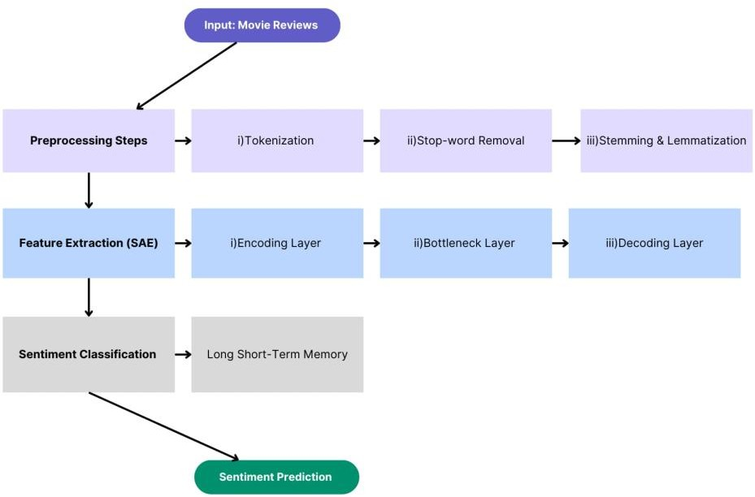

**3.1 Block Diagram of the Existing System**

## EXISTING SYSTEM ALGORITHM AND METHODOLOGY

The existing system employs a two-phase methodology involving unsupervised and supervised learning stages:

#### Data Preprocessing:

Initially, textual data from IMDb reviews is preprocessed through tokenization, normalization, and padding to create uniform-length sequences suitable for neural network input.

#### Stacked Auto-Encoder (SAE) for Feature Extraction:

In the unsupervised learning stage, SAE, a deep neural network with multiple hidden layers, is trained to reconstruct the input data. The SAE learns hierarchical, compressed representations of the input text data by minimizing reconstruction error. These learned features effectively capture significant textual patterns while reducing dimensional complexity.

#### Long Short-Term Memory (LSTM) Classifier:

In the supervised learning stage, the extracted SAE features are utilized as inputs for the LSTM classifier, a specialized form of Recurrent Neural Network designed to handle sequential data. The LSTM layers efficiently capture temporal dependencies and long-range context within reviews, leading to more accurate sentiment predictions. The final output layer classifies each review into binary sentiment labels: positive or negative. The hybrid model was tested on various train-test splits of the IMDb dataset (such as 80/20, 85/15, and 90/10), with the best result achieved at a 90/10 split, yielding an accuracy of 87%.

## EXISTING SYSTEM ALGORITHM AND METHODOLOGY

The existing system effectively addressed some limitations of traditional sentiment analysis models by integrating a hybrid approach combining unsupervised feature extraction (Stacked Auto-Encoders) and supervised sequential classification (LSTM networks). The primary strengths of this system lie in its ability to capture deep semantic features and sequential dependencies from textual data, significantly enhancing sentiment classification performance. However, despite these strengths, the system still faces challenges such as computational complexity, the requirement of substantial training time, and limited ability to capture contextual nuances thoroughly. These limitations highlight the scope for improvement, particularly through advanced transformer-based architectures, such as RoBERTa, complemented by data augmentation strategies—which are the core innovations proposed in our current project.

# CHAPTER 4 PROPOSED SYSTEM

## CHAPTER 4 PROPOSED SYSTEM

* 1. **OVERVIEW OF THE PROPOSED SYSTEM**

The proposed system introduces an advanced sentiment analysis framework that leverages the RoBERTa (Robustly Optimized BERT Approach) transformer model combined with a novel synonym-based Data Augmentation technique to enhance accuracy and robustness. RoBERTa, an optimized transformer-based language model, significantly improves contextual language understanding over traditional and other deep-learning methods. By integrating synonym replacement through WordNet, the system effectively doubles the size of the original dataset, introduces lexical diversity, and mitigates model overfitting. The primary objective is to develop a highly accurate sentiment classifier capable of reliably predicting sentiments in movie reviews from the IMDb dataset. The combination of RoBERTa with augmented data results in superior performance metrics, achieving an accuracy of 92.72%, outperforming previous models, including traditional machine learning and existing hybrid deep learning systems.

## BLOCK DIAGRAM OF THE PROPOSED SYSTEM

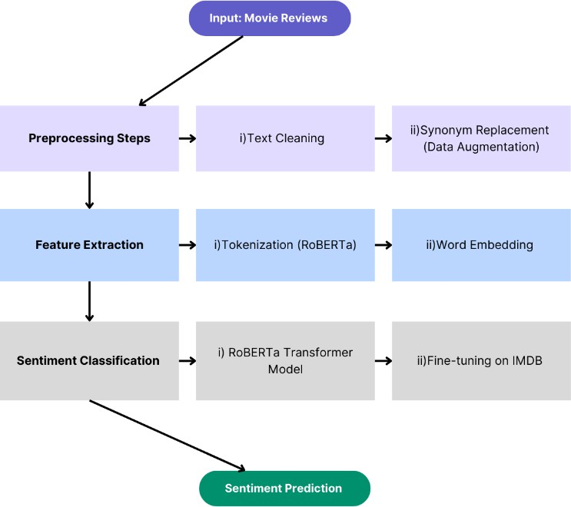

**4.1 Block Diagram of the Proposed System**

## PROPOSED SYSTEM ALGORITHM & METHODOLOGY

The proposed methodology consists of the following major stages:

#### Data Collection and Preprocessing:

Initially, 50,000 movie reviews from the IMDb dataset are collected and preprocessed. Textual data undergoes tokenization, normalization, and cleaning steps to remove irrelevant characters and ensure consistent formatting.

#### Synonym-based Data Augmentation:

A novel data augmentation strategy utilizing WordNet is implemented to enrich the original dataset. For each review, synonym replacement is performed, creating semantically similar but lexically diverse sentences. This process effectively doubles the dataset from 50,000 reviews to a total of 100,000 reviews, significantly enhancing the model's robustness and generalization capability.

#### RoBERTa Tokenization (Hugging Face API):

The augmented textual data is tokenized using Hugging Face's RoBERTa tokenizer. This step involves encoding text into numerical tokens suitable for the RoBERTa model, including padding, truncation, and attention masks generation, ensuring consistency in input sequence lengths.

#### RoBERTa Transformer Fine-Tuning (TensorFlow/Keras):

A pre-trained roberta-base transformer model is fine-tuned on the augmented IMDb dataset. The model leverages the transfer learning capabilities of RoBERTa, which has been extensively pre-trained on large corpora. Fine-tuning involves adjusting the RoBERTa parameters specifically for sentiment classification using TensorFlow and the AdamW optimization algorithm. The training occurs over multiple epochs, employing a validation strategy to monitor model performance.

#### Evaluation and Deployment:

The fine-tuned RoBERTa model is rigorously evaluated using performance metrics such as accuracy, precision, recall, F1-score, and ROC-AUC. The system achieved a superior accuracy of 92.72%, clearly surpassing previous traditional and deep learning-based models. Additionally, a custom-built user-friendly frontend application allows real-time sentiment prediction, offering practical deployment capabilities for user interaction.

## SUMMARY

The proposed sentiment analysis system addresses critical limitations identified in existing literature and previous systems by integrating advanced transformer-based architectures (RoBERTa) with effective synonym-based data augmentation. This methodology significantly enhances sentiment prediction accuracy and generalization capability. With a reported accuracy of 92.72% on the IMDb dataset, the proposed approach demonstrates a substantial improvement over prior approaches such as Hybrid SAE-LSTM (87%) [1], classical machine learning models (79%-85%) [3,4,6,7,9],

ensemble techniques (83%) [5], and RNN-based methods (86.64%) [8]. Additionally, the implementation of a real-time sentiment prediction frontend further demonstrates the system's practical utility. Overall, this innovative approach positions itself as a robust solution for sentiment classification tasks and highlights potential future advancements through further model optimization and multilingual extensions.

# CHAPTER 5 IMPLEMENTATION SETUP

## CHAPTER 5 IMPLEMENTATION SETUP

* 1. **DATASET**

The dataset utilized in this project is the IMDb movie review dataset, a widely- recognized and benchmarked collection within sentiment analysis research. It comprises a total of 50,000 textual reviews, evenly distributed into two categories: 25,000 reviews labeled as positive and another 25,000 as negative. Each review consists of extensive textual data, containing rich and diverse linguistic patterns suitable for training complex Natural Language Processing (NLP) models. The balanced nature of the dataset ensures fair representation, aiding in unbiased model training and accurate evaluation of predictive capabilities.

## TOOLS AND TECHNOLOGIES USED

The following tools and technologies were employed in implementing the project:

* + - **Programming Language:** Python 3.x
    - **Machine Learning & Deep Learning Libraries:** TensorFlow, Keras, scikit-learn
    - **Natural Language Processing:** Hugging Face Transformers, NLTK (WordNet)
    - **Data Handling:** Pandas, NumPy
    - **Visualization:** Matplotlib, Seaborn
    - **Frontend/Web Development**: HTML, CSS, Bootstrap
    - **Runtime Environment:** Google Colab, Jupyter Notebook
    - **Deployment Framework:** Flask

## DATA LOADING AND EXPLORATION

Initially, the IMDb dataset was loaded into a structured Pandas DataFrame, facilitating efficient data handling and exploration. Exploratory data analysis (EDA) procedures included assessing the dataset’s size, label distribution, and basic statistics.

Detailed data exploration ensured the dataset was balanced with equal representation of positive and negative sentiments, verifying data integrity. Random samples were manually reviewed to gain insights into linguistic variations, sentence structure, length distribution, and vocabulary complexity, aiding informed preprocessing decisions in subsequent steps.

## DATA PRE-PROCESSING

In preparation for effective modeling, substantial pre-processing was conducted. Sentiment labels initially represented as textual categories ("positive" and "negative") were converted into numerical binary labels (1 for positive, 0 for negative). Further text preprocessing involved tokenizing textual data using Hugging Face’s RoBERTa tokenizer, which provided tokenization, padding, and attention mask generation capabilities. This ensured consistency in sequence length across samples, critical for stable model performance. After preprocessing, the dataset was partitioned into an 80%-20% training-testing split, enabling reliable evaluation of the model’s performance on unseen data.

## AUGMENTATION USING SYNONYM REPLACEMENT

To significantly enhance model robustness and reduce the potential for overfitting, synonym-based data augmentation was implemented using the WordNet lexical database. Each original review underwent selective synonym replacement at the word level, creating augmented reviews that maintained the semantic meaning but introduced lexical variability. This strategic augmentation process doubled the dataset’s size from 50,000 to approximately 100,000 reviews. The resulting augmented dataset introduced additional linguistic diversity, enabling the RoBERTa model to generalize more effectively and perform robustly on new, unseen textual data.

## MODEL BUILDING AND TRAINING

The core model employed in this project was RoBERTa-base, a state-of-the-art transformer-based NLP model. Pre-trained on extensive linguistic corpora, RoBERTa is adept at capturing nuanced contextual information within text. For this project, RoBERTa was fine-tuned specifically for binary sentiment classification using TensorFlow and Keras frameworks. The fine-tuning process involved using the AdamW optimizer with a learning rate of 3e-5 and a Binary Cross-Entropy loss function to optimize model parameters. Model training occurred over three epochs, with batch sizes of 32 and a validation split of 10% to continuously monitor performance and mitigate overfitting risks.

## MODEL EVALUATION AND PERFORMANCE METRICS

After successful fine-tuning, the RoBERTa model underwent comprehensive evaluation using various metrics such as accuracy, precision, recall, F1-score, and ROC-AUC. Evaluations were performed on a dedicated test dataset, separate from the training and validation sets. The proposed model demonstrated exceptional performance, achieving an accuracy of 92.72%, an F1-score of 0.93, and a ROC-AUC score of 0.98. These metrics significantly surpassed performances reported in previous studies employing traditional machine learning methods and earlier deep learning architectures, clearly highlighting the advantages offered by the transformer-based RoBERTa model coupled with synonym-based data augmentation.

## MODEL PREDICTION AND INFERENCE

For sentiment prediction, the trained RoBERTa model processed unseen movie reviews from the test dataset. Model inference involved passing preprocessed textual inputs through the fine-tuned transformer layers, producing logit outputs. These logits were subsequently converted to probabilities through a sigmoid activation function, establishing a threshold of 0.5 to classify sentiments as positive or negative.

Predicted labels were then systematically compared with ground-truth labels, confirming the model’s high predictive accuracy and reliability, and validating the effectiveness of the proposed methodology.

## VISUALIZATION OF RESULTS

Visualization techniques were strategically employed to interpret model performance intuitively. Matplotlib and Seaborn generated clear visual representations of various metrics and outcomes, including accuracy and loss curves for both training and validation phases, confusion matrices depicting classification accuracy per sentiment class, and Receiver Operating Characteristic (ROC) curves indicating overall predictive performance. These visualizations provided valuable insights into model strengths, clarified potential limitations, and facilitated clearer communication of results and findings to stakeholders.

## MODEL DEPLOYMENT

To demonstrate real-world applicability and enhance user interaction, a functional, intuitive web-based interface was developed using Flask, supported by HTML, CSS, and Bootstrap for frontend design. This deployment allowed users to input individual movie reviews through a responsive, visually appealing web application. Real-time predictions were instantly generated by the trained RoBERTa model, displaying clear and concise sentiment classifications. The interface, designed with an engaging dark-themed, terminal-like aesthetic, significantly improved user experience, showcasing the practical implementation and usability of the sentiment analysis system.

## SUMMARY

The implementation setup of this project encompassed rigorous data exploration, meticulous preprocessing steps, an innovative synonym-based data augmentation strategy, and fine-tuning of an advanced RoBERTa transformer model. Comprehensive evaluation demonstrated the proposed system's effectiveness, achieving superior accuracy compared to traditional and previously explored deep- learning techniques. The creation of an intuitive, real-time prediction web application further emphasized the system’s practical utility and readiness for broader deployment.

# CHAPTER 6 RESULTS AND INFERENCES

## CHAPTER 6 IMPLEMENTATION SETUP

* 1. **EVALUATION METRICS**

In evaluating the performance of the proposed RoBERTa-based sentiment analysis model, multiple standard metrics were employed:

**Accuracy**: Measures the proportion of correctly classified sentiment predictions (both positive and negative) out of all predictions made. Higher accuracy indicates superior predictive performance, with a score of 1 representing perfect classification.



**Precision:** Reflects the model’s capability to correctly identify positive sentiments among all reviews predicted as positive, thus emphasizing prediction reliability. High precision implies fewer false-positive outcomes.



**Recall:** Evaluates the model’s ability to correctly detect actual positive sentiments among all genuine positive reviews. A higher recall score signifies effective identification of true positives, reducing false-negative rates.



**F1-score:** Provides a balanced measure combining precision and recall into a single metric, especially critical when the dataset is balanced. Higher F1-score values closer to 1 indicate superior overall classification performance.



**ROC-AUC:** Quantifies the model’s effectiveness at distinguishing between positive and negative sentiments, independent of classification thresholds. A ROC-AUC score closer to 1 denotes strong discriminatory ability.



## RESULTS

The detailed results of the proposed RoBERTa model evaluated on the IMDb movie review dataset are summarized as follows:

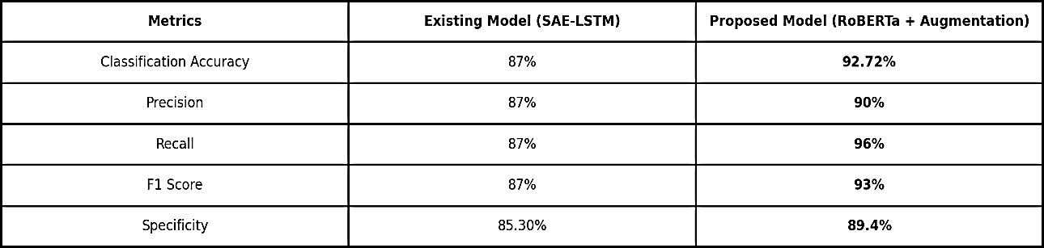

#### Table 6.1 Evaluation Results of Proposed RoBERTa Model

The proposed RoBERTa-based sentiment achieves an accuracy of **92.72%.** This demonstrates superior effectiveness in capturing linguistic context and sentiment nuances.

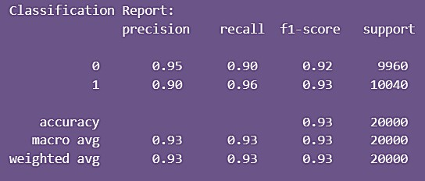

#### Table 6.2 Classification Report

Further, visual evaluations provide clear evidence of superior performance: **Confusion Matrix:** Clearly indicated a low rate of misclassifications, verifying the robustness and reliability of predictions.

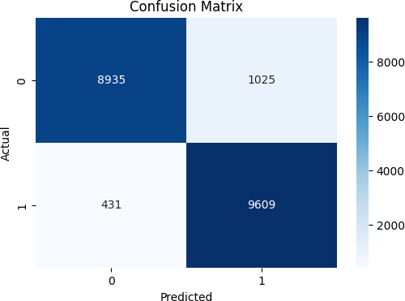

#### Confusion Matrix

**ROC Curve:** Demonstrated a highly effective distinction between positive and negative sentiment classes, validating the high ROC-AUC score (0.9799).

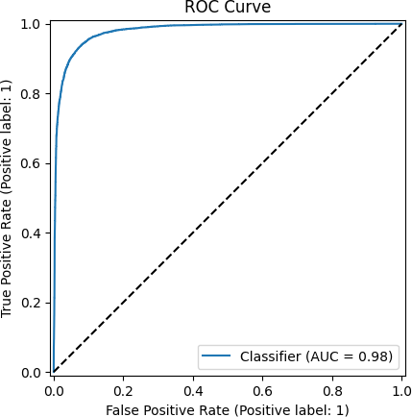

#### ROC Curve

**Accuracy and Loss Curves**: Confirmed stable training dynamics, with rapid convergence to high accuracy and low loss across training epochs.

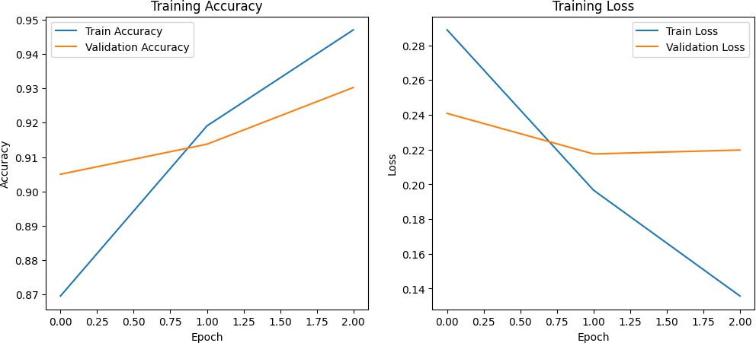

#### Accuracy and Loss Curves

The results clearly illustrate substantial improvements in accuracy, precision, recall, and overall classification capability, highlighting the effectiveness of combining advanced transformer architectures with data augmentation techniques for sentiment analysis tasks.

## SUMMARY

The evaluation results strongly underscore the proposed RoBERTa model’s capability to accurately classify movie review sentiments. The metrics employed, particularly accuracy **(92.72%)**, F1-score **(0.93)**, and ROC-AUC **(0.9799)**, reflect superior performance compared to traditional machine learning and existing deep learning methodologies. The achieved outcomes validate the effectiveness of advanced transformer-based models, enhanced by synonym-based data augmentation, in accurately capturing complex sentiment expressions within textual data. The findings from this evaluation provide compelling evidence supporting the practical application of the proposed approach for real-world sentiment analysis, facilitating more accurate, context-sensitive insights into user opinions and behaviors.

# CHAPTER 7 CONCLUSION AND FUTURE WORK

## CHAPTER 7 CONCLUSION AND FUTURE WORK

The Sentiment Analysis System for Movie Reviews developed in this project utilizes the power of transformer-based deep learning, specifically the RoBERTa model, enhanced with data augmentation, to classify sentiment with high accuracy. Through a systematic approach encompassing data preprocessing, synonym-based augmentation, model fine-tuning, evaluation, and deployment, the project demonstrates the efficacy of modern Natural Language Processing (NLP) techniques in capturing sentiment from unstructured text.

The proposed system was evaluated on the IMDb dataset and achieved a notable classification accuracy of 92.72%, outperforming traditional machine learning methods and existing deep learning models such as SAE-LSTM, Naïve Bayes, SVM, and RNN variants. The integration of synonym replacement for data augmentation contributed significantly to model generalization and robustness, while the deployment of a user- friendly web interface enabled real-time interaction with the model for practical applications.

Looking ahead, several promising directions exist for extending and improving the current system:

* **Multiclass Sentiment Handling:** Incorporating neutral or mixed sentiment categories to move beyond binary classification, enabling more granular opinion mining.
* **Model Expansion:** Exploring larger or more recent transformer architectures like RoBERTa-large, DeBERTa, or GPT variants to further improve classification performance.
* **Multilingual Support:** Extending the system to support sentiment analysis across multiple languages using multilingual models such as XLM-RoBERTa.

By exploring these future avenues, the system can evolve into a more comprehensive, intelligent, and inclusive sentiment analysis platform suitable for diverse domains including social media monitoring, customer feedback systems, and market analysis.

## REFERENCES

1. Kaur, G., & Sharma, A. “Sentiment Analysis Using Hybrid Model of Stacked Auto- Encoder-Based Feature Extraction and Long Short-Term Memory-Based Classification Approach”, Journal of Big Data, Vol. 10, Article 5, 2023.
2. Timmaraju, A. “Sentiment Analysis on Movie Reviews Using Recursive and Recurrent Neural Network Architectures”, Stanford University Technical Report, 2015.
3. Shirani-Mehr, H. “Sentiment Analysis for Movie Reviews”, University of California, San Diego, Technical Report, 2014.
4. Chase, C., & Nguyen, A. “Sentiment Analysis on Movie Reviews”, McGill University NLP Study, 2015.
5. Mesnil, G., Mikolov, T., Ranzato, M., & Bengio, Y. “Ensemble of Generative and Discriminative Techniques for Sentiment Analysis of Movie Reviews”, arXiv preprint arXiv:1412.5335, 2014.
6. Mohan, M., & Singh, R. “Sentiment Analysis of Online Movie Reviews Using Machine Learning”, International Journal of Advanced Computer Science and Applications, Vol. 11, No. 9, pp. 634–640, 2020.
7. Roberts, I., & Yan, L. “Vector-Based Sentiment Analysis of Movie Reviews”, Stanford CS229 Project Report, 2014.
8. Nair, S., & Soni, S. “Sentiment Analysis on Movie Reviews Using Recurrent Neural Networks”, IRE Journal, Vol. 2, Issue 6, 2018.
9. Jain, A., & Gupta, R. “Sentiment Analysis for Movie Reviews”, Academia.edu White Paper, 2014.
10. Kaur, R., & Bala, A. “Sentiment Analysis Techniques: A Comprehensive Review Across Movie Reviews”, International Research Journal of Engineering and Technology (IRJET), Vol. 5, Issue 5, pp. 3201–3204, 2022.
11. Zhou, X., Wan, X., & Xiao, J. “Attention-Based LSTM Network for Cross-Lingual Sentiment Classification”, Proceedings of the Conference on Empirical Methods in Natural Language Processing (EMNLP), pp. 247–256, 2016.
12. Shahnawaz, & Astya, P. “Sentiment Analysis: Approaches and Open Issues”, Proceedings of the International Conference on Computing, Communication and Automation (ICCCA), pp. 154–158, May 2017.
13. Jnoub, N., Al Machot, F., & Klas, W. “A Domain-Independent Classification Model for Sentiment Analysis Using Neural Models”, Applied Sciences, Vol. 10, No. 18,

p. 6221, September 2020.

1. Ahmed, K., Nadeem, M. I., Li, D., Zheng, Z., Ghadi, Y. Y., Assam, M., & Mohamed, H. G. “Exploiting Stacked Autoencoders for Improved Sentiment Analysis”, Applied Sciences, Vol. 12, No. 23, p. 12380, December 2022.
2. Fan, A., Lavril, T., Grave, E., Joulin, A., & Sukhbaatar, S. “Addressing Some Limitations of Transformers with Feedback Memory”, arXiv preprint, arXiv:2002.09402, 2020.
3. Kumar, C. H., & Kumar, R. S. “Natural Language Processing of Movie Reviews to Detect the Sentiments Using Novel Bidirectional Encoder Representation-BERT for Transformers Over Support Vector Machine”, Journal of Pharmaceutical Negative Results, pp. 619–628, September 2022.
4. Sun, C., Qiu, X., Xu, Y., & Huang, X. “How to Fine-Tune BERT for Text Classification?”, Proceedings of the 18th China National Conference on Computational Linguistics (CCL), Kunming, China, pp. 194–206, October 2019.
5. Yang, Z., Dai, Z., Yang, Y., Carbonell, J., Salakhutdinov, R., & Le, Q. V. “XLNet: Generalized Autoregressive Pretraining for Language Understanding”, Proceedings of the Advances in Neural Information Processing Systems (NeurIPS), Vol. 32, pp. 1–11, 2019.
6. Su, S. “Sentimental Analysis Applied on Movie Reviews”, Journal of Education, Humanities and Social Sciences, Vol. 3, pp. 188–195, September 2022.
7. Maity, D., Kanakaraddi, S., & Giraddi, S. “Text Sentiment Analysis Based on Multichannel Convolutional Neural Networks and Syntactic Structure”, Procedia Computer Science, Vol. 218, pp. 220–226, January 2023.

# APPENDIX A SOURCE CODE

## APPENDIX A SOURCE CODE

**Notebook:**

import numpy as np import pandas as pd

import matplotlib.pyplot as plt import seaborn as sns

import tensorflow as tf

from sklearn.model_selection import train_test_split

from sklearn.metrics import (accuracy_score, classification_report, roc_auc_score, confusion_matrix, RocCurveDisplay)

from transformers import (AutoTokenizer, TFRobertaForSequenceClassification, AdamWeightDecay)

import nltk

from nltk.corpus import wordnet import warnings warnings.filterwarnings('ignore') # Load dataset

data = pd.read_csv("/content/IMDB.csv") print("Dataset Shape:", data.shape) data.head()

# Convert sentiment to numerical values

data['sentiment'] = data['sentiment'].map({'positive': 1, 'negative': 0})

# Data Augmentation Function nltk.download('wordnet') nltk.download('omw-1.4')

def synonym_replacement(sentence): words = sentence.split() new_sentence = []

for word in words:

synonyms = wordnet.synsets(word) if synonyms:

synonym = synonyms[0].lemmas()[0].name() new_sentence.append(synonym)

else:

new_sentence.append(word) return " ".join(new_sentence)

# Apply augmentation

print("\nApplying Data Augmentation...")

data['augmented_review'] = data['review'].apply(synonym_replacement) augmented_data = pd.DataFrame({

'review': data['augmented_review'], 'sentiment': data['sentiment']

})

data = pd.concat([data, augmented_data]) print("Augmented Dataset Shape:", data.shape)

# Initialize tokenizer

tokenizer = AutoTokenizer.from_pretrained("roberta-base")

# Train-test split

X_train, X_test, y_train, y_test = train_test_split( data['review'], data['sentiment'],

test_size=0.2, random_state=42

)

# Tokenization function

def preprocess_texts(texts, max_length=128): return tokenizer(

list(texts), max_length=max_length, padding=True, truncation=True, return_tensors="tf"

)

print("\nTokenizing Data...") train_encodings = preprocess_texts(X_train) test_encodings = preprocess_texts(X_test)

def build_model():

model = TFRobertaForSequenceClassification.from_pretrained( "roberta-base",

num_labels=1

)

optimizer = AdamWeightDecay(learning_rate=3e-5, weight_decay_rate=0.01) model.compile(

optimizer=optimizer, loss=tf.keras.losses.BinaryCrossentropy(from_logits=True), metrics=["accuracy"]

)

return model

print("\nBuilding Model...") model = build_model() model.summary()

print("\nStarting Training...") history = model.fit(

x={"input_ids": train_encodings["input_ids"], "attention_mask": train_encodings["attention_mask"]},

y=y_train.values, validation_split=0.1,

epochs=3, batch_size=32

)

# Training History Visualization plt.figure(figsize=(12, 5))

plt.subplot(1, 2, 1)

plt.plot(history.history['accuracy'], label='Train Accuracy') plt.plot(history.history['val_accuracy'], label='Validation Accuracy') plt.title('Training Accuracy')

plt.ylabel('Accuracy') plt.xlabel('Epoch') plt.legend()

plt.subplot(1, 2, 2)

plt.plot(history.history['loss'], label='Train Loss') plt.plot(history.history['val_loss'], label='Validation Loss') plt.title('Training Loss')

plt.ylabel('Loss') plt.xlabel('Epoch') plt.legend() plt.show()

print("\nEvaluating Model...") predictions = model.predict({

"input_ids": test_encodings["input_ids"], "attention_mask": test_encodings["attention_mask"]

})

predicted_probs = tf.nn.sigmoid(predictions.logits).numpy().flatten() predicted_labels = (predicted_probs > 0.5).astype(int)

# Metrics

print("Accuracy:", accuracy_score(y_test, predicted_labels)) print("Classification Report:\n", classification_report(y_test, predicted_labels)) print("ROC AUC:", roc_auc_score(y_test, predicted_probs))

# Confusion Matrix

cm = confusion_matrix(y_test, predicted_labels) plt.figure(figsize=(6, 4))

sns.heatmap(cm, annot=True, fmt='d', cmap='Blues') plt.title('Confusion Matrix')

plt.xlabel('Predicted') plt.ylabel('Actual') plt.show()

# ROC Curve

RocCurveDisplay.from_predictions(y_test, predicted_probs) plt.title('ROC Curve')

plt.plot([0, 1], [0, 1], 'k--')

plt.show()

models = ['SAE-LSTM (Existing)', 'BERT + Synonym', 'RoBERTa (Proposed)'] accuracies = [0.87, 0.89, 0.93]

plt.figure(figsize=(8, 6))

plt.bar(models, accuracies, color=['#1f77b4', '#ff7f0e', '#2ca02c']) plt.ylim(0.8, 1.0)

plt.ylabel('Accuracy')

plt.title('Model Accuracy Comparison') for i, v in enumerate(accuracies):

plt.text(i, v+0.01, f"{v*100:.1f}%", ha='center') plt.show()

print("\nSaving Model...") model.save_pretrained('sentiment_model') tokenizer.save_pretrained('sentiment_model')

# Verify model saving try:

loaded_model = TFRobertaForSequenceClassification.from_pretrained('sentiment_model')

print("Model saved successfully!") except:

print("Error in saving model!") from google.colab import drive drive.mount('/content/drive')

# Save model and tokenizer model.save_pretrained('/content/drive/MyDrive/sentiment_model') tokenizer.save_pretrained('/content/drive/MyDrive/sentiment_model')

# Alternative: Download directly

!zip -r sentiment_model.zip sentiment_model/ from google.colab import files files.download('sentiment_model.zip')

## app.py:

from flask import Flask, render_template, request, redirect, url_for, session from transformers import TFRobertaForSequenceClassification, AutoTokenizer from deep_translator import GoogleTranslator

import tensorflow as tf

app = Flask( name )

app.secret_key = 'supersecretkey' # required for session

# Load model and tokenizer MODEL_PATH = "./sentiment_model"

model = TFRobertaForSequenceClassification.from_pretrained(MODEL_PATH) tokenizer = AutoTokenizer.from_pretrained(MODEL_PATH)

# Sentiment prediction function def predict_sentiment(text):

inputs = tokenizer(text, return_tensors="tf", truncation=True, padding=True, max_length=128)

logits = model(inputs).logits

prob = tf.nn.sigmoid(logits)[0].numpy()[0] return "Positive" if prob > 0.5 else "Negative"

# Translation function

def translate_to_english(text): try:

return GoogleTranslator(source='auto', target='en').translate(text) except Exception as e:

print("Translation error:", e)

return text # fallback: return original

# Routes

@app.route("/", methods=["GET", "POST"]) def index():

if request.method == "POST": original_review = request.form["review"]

translated_review = translate_to_english(original_review) sentiment = predict_sentiment(translated_review)

session["review"] = original_review session["sentiment"] = sentiment

return redirect(url_for("index")) return render_template(

"index.html", review=session.pop("review", ""), sentiment=session.pop("sentiment", None)

)

if name == " main ": app.run(debug=True)

## templates/index.html:

<!DOCTYPE html>

<html lang="en">

<head>

<meta charset="UTF-8">

<title>Sentiment Analysis</title>

<link href=["https://cdn.jsdelivr.net/npm/bootstrap@5.3.0/dist/css/bootstrap.min.css"](https://cdn.jsdelivr.net/npm/bootstrap%405.3.0/dist/css/bootstrap.min.css) rel="stylesheet" />

<link href="https://fonts.googleapis.com/css2?family=VT323&display=swap" rel="stylesheet" />

<style> body {

background-color: #000; color: #fff;

font-family: 'VT323', monospace; margin: 0;

padding: 0;

}

h1 {

font-size: 3rem; color: #ff0;

text-shadow:

0 0 5px #ff0,

0 0 10px #ff0,

0 0 20px #ff0,

0 0 40px #ff0;

}

::placeholder { color: #aaa; opacity: 1;

}

.form-control {

background-color: #222 !important; color: #fff !important;

border: 1px solid #ff0 !important; height: 180px !important;

width: 80% !important; margin: auto;

font-size: 1.5rem;

}

.form-control:focus {

box-shadow: 0 0 5px #ff0 !important; outline: none !important;

}

.btn-primary, .btn-reset { background-color: #ff0 !important; border-color: #ff0 !important; color: #000 !important;

font-weight: bold; transition: transform 0.2s; font-size: 1.5rem;

}

.btn-primary:hover, .btn-reset:hover { transform: scale(1.1);

}

.card {

background-color: #111; border: 1px solid #ff0;

box-shadow: 0 0 10px #ff0;

width: 80%;

margin: 0 auto;

height: 160px !important;

}

.card-header { background-color: #222; color: #ff0;

font-weight: bold;

border-bottom: 1px solid #ff0;

}

.card-body { color: #fff;

font-size: 1.3rem;

}

.card-body strong { color: #ff0;

}

</style>

</head>

<body>

<div class="container py-5">

<h1 class="text-center mb-4">Sentiment Analysis Of Movie Reviews</h1>

<form id="reviewForm" method="POST" class="mb-4">

<div class="mb-3 text-center">

<textarea

class="form-control" id="review" name="review"

placeholder="Enter your review here"

>{{ review }}</textarea>

</div>

<div class="text-center d-flex justify-content-center gap-3">

<input type="submit" value="Analyze" class="btn btn-primary" />

<button type="button" class="btn btn-reset" onclick="clearForm()"> Clear

</button>

</div>

</form>

{% if sentiment %}

<div class="card mt-4" id="resultCard">

<div class="card-header">Result:</div>

<div class="card-body">

<p class="card-text"><strong>Review:</strong> {{ review }}</p>

<p class="card-text"><strong>Sentiment:</strong> {{ sentiment }}</p>

</div>

</div>

{% endif %}

</div>

<script>

function clearForm() { document.getElementById("review").value = "";

const resultCard = document.getElementById("resultCard"); if (resultCard) {

resultCard.style.display = "none";

}

}

</script>

<script src=["https://cdn.jsdelivr.net/npm/bootstrap@5.3.0/dist/js/bootstrap.bundle.min.js"><](https://cdn.jsdelivr.net/npm/bootstrap%405.3.0/dist/js/bootstrap.bundle.min.js)/sc ript>

</body>

</html>

# APPENDIX B SANPSHOTS

**APPENDIX B**

**SNAPSHOTS**

**DATASET**

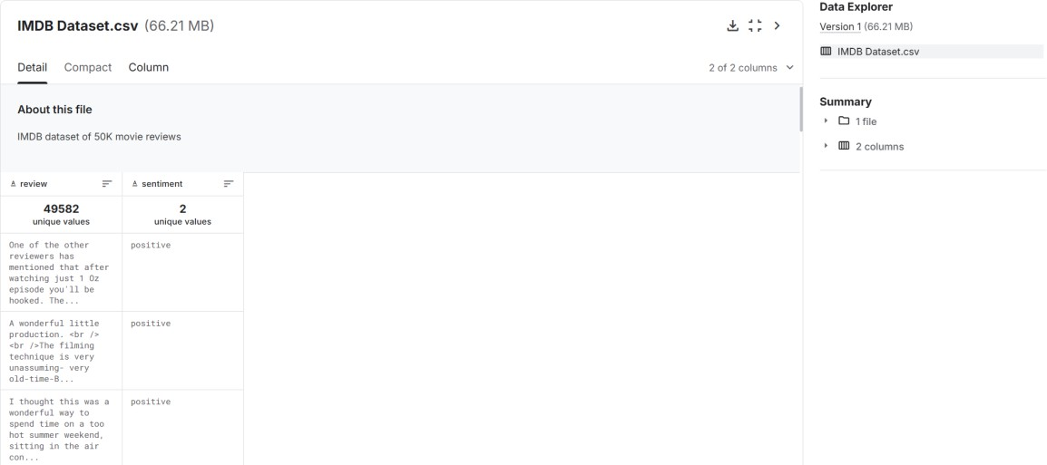

* 1. **Dataset**

## ACCURACY SCORE:

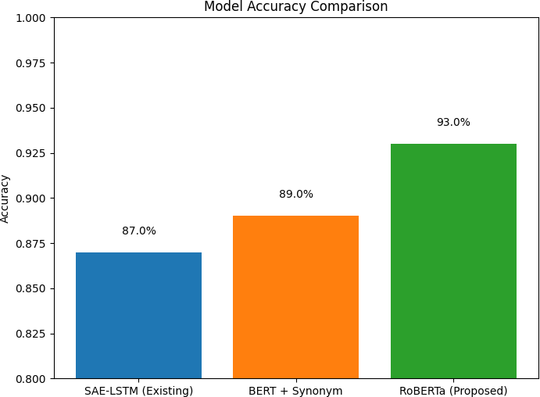

* 1. **Accuracy Score**

## WEB INTERFACE:

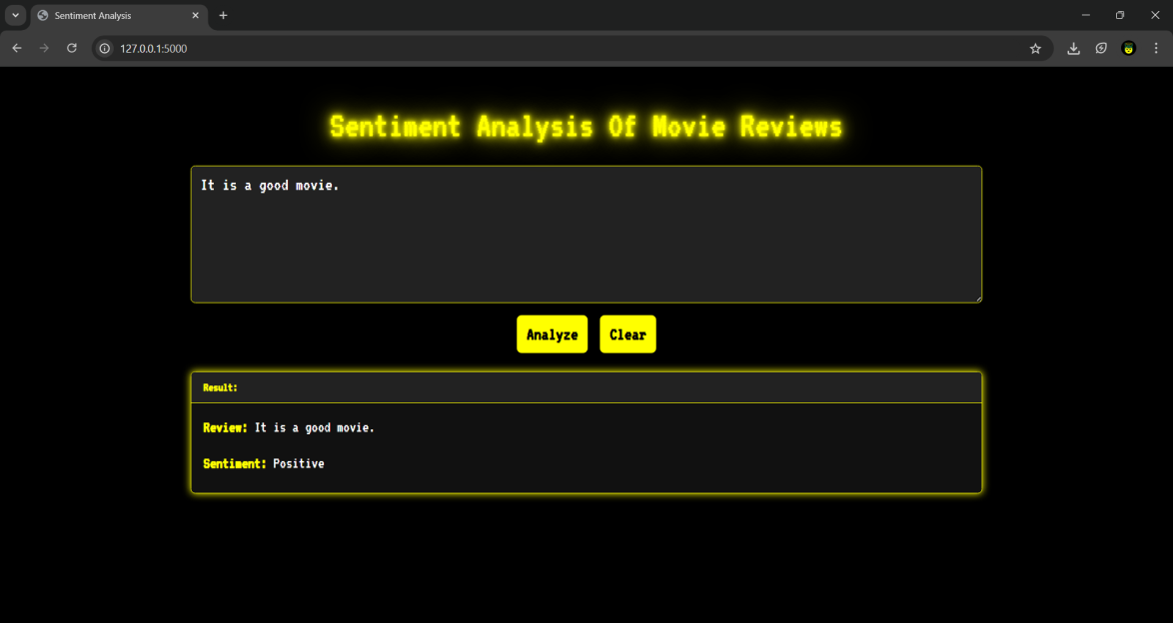

* 1. **Web Interface 1**

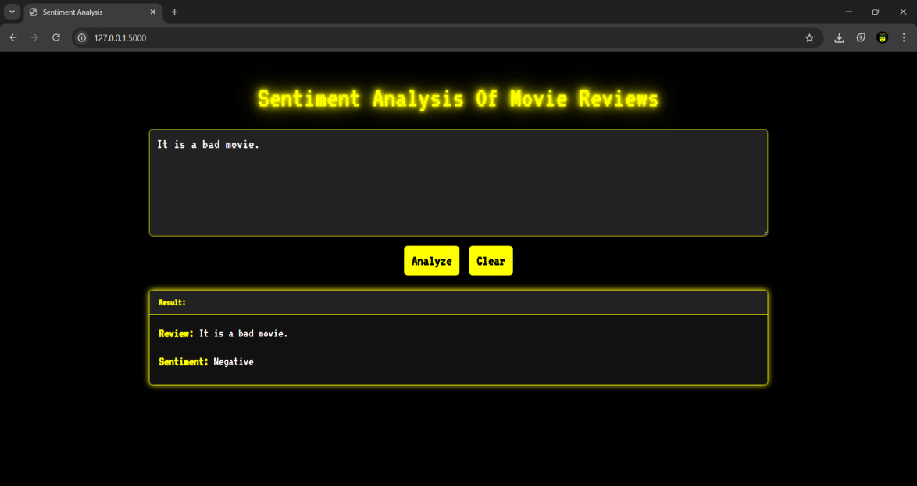

* 1. **Web Interface 2**

# APPENDIX C CERTIFICATES

**APPENDIX C CERTIFICATES**

